DEALS TO VENICE BEACH

The Venice Beach neighborhood in Los Angeles had been a seaside destination since the early 1900’s and is known for it’s distinct personality. With a vibrant mix of attractions, Venice Beach offers everything from casual beach activities, to unique shopping, to diverse entertainment. Book a trip to Venice Beach via Los Angeles International Airport on Virgin America. Live it up at 35,000 feet with WiFi, on-demand entertainment, and more on every flight.

(MARKET IMAGE HERE)

Find Deals From These Cities

INSERT FARE GRID FROM / TO Version (if available!)

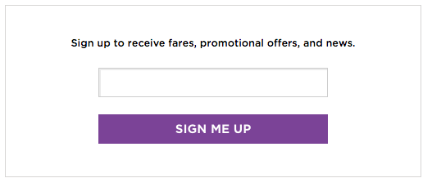   
Top Things To Do in Venice Beach

When visiting Venice Beach, be sure to try some of the recommendations below.

* Stroll the Venice Boardwalk and enjoy the wonderful variety of street entertainers, artists, and people watching along this ocean front walk at any given time of the year.
* Shop on Abbot Kinney Blvd., Venice Beach’s famous block of independent boutiques, galleries, restaurants, bars, and organic coffee shops. This is an absolute must for shopaholics.
* See the beauty of the Venice Canals. Inspired by Venice, Italy, these canals run between multi-million dollar homes along several blocks.

Travel Tips and Resources

[Must-Dos in Venice Beachhttp://venicebeach.com/things-to-do-in-venice](http://venicebeach.com/things-to-do-in-venice)

[Venice Beach Hotels](http://www.tripadvisor.com/HotelsNear-g32655-d104591-Venice_Beach-Los_Angeles_California.html)

[Venice Beach Restaurants](https://www.zagat.com/l/los-angeles/best-restaurants-in-venice)

[Venice Beach Shopping Guidehttp://www.venicebeachliving.com/cm/shopping.html](http://www.venicebeachliving.com/cm/shopping.html)

[Venice Beach Nightlife and Entertainmenthttp://www.lanightlife.com/neighborhoods/nlist/name/venice](http://www.lanightlife.com/neighborhoods/nlist/name/venice)

[Venice Beach Travel Tipshttp://venicebeach.com/venice-survival-guide-venice-101](http://venicebeach.com/venice-survival-guide-venice-101)

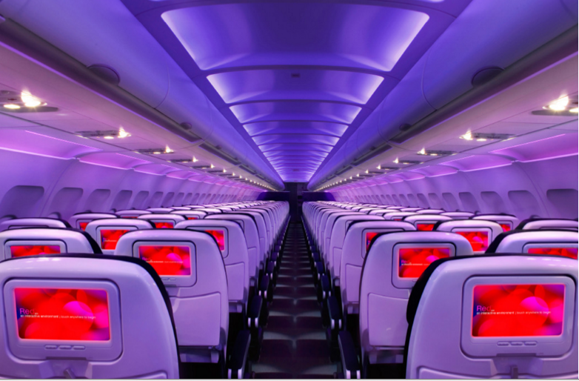

Main Cabin Main Cabin Select First Class

(add links to Cabin Class Pages)

Ready. Set. Fly.

Book your Mood-lit Ride to Venice Beach.

When traveling to Venice Beach, book a flight to Los Angeles International with Virgin America. Once you’re in L.A., Venice Beach is just a 15 minute drive away. Flying with us, you’ll have access to the utmost in airline amenities - from our on demand food ordering and WiFi, to our mood-lit cabins and custom-designed leather seats. Fly with Virgin America and experience joy in the sky.

Take a Virtual Tour

Add Terms & Conditions